Chapter 19, Problem 23.

- Find the y parameters for the two-port in Fig. 19.84.
- Determine V₂(s) for v_{s} = 2u(t) V.

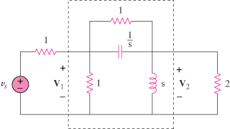

Figure 19.84
For Prob. 19.23.

